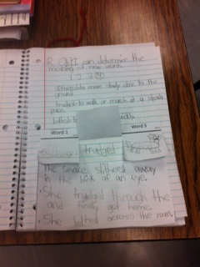**[](http://cd.pbsstatic.com/l/66/5866/9780873585866.jpg)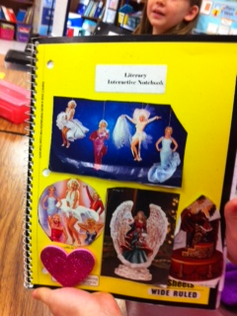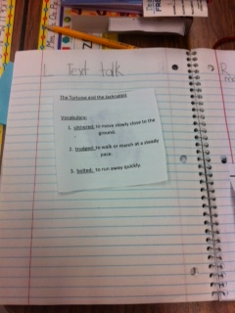Text Talk Interactive Notebook Example**

**Student Side**

**Cover**

**Teacher Side**